Biology |  | Mr. Rodrigo
Name |  |  | Period
Worksheet |  | Arthropods
Introduction:
Even if you have never heard the word arthropod before, you have seen and probably even eaten arthropods many times. A beetle is an arthropod. A spider is an arthropod. A lobster is an arthropod.

Arthropods:
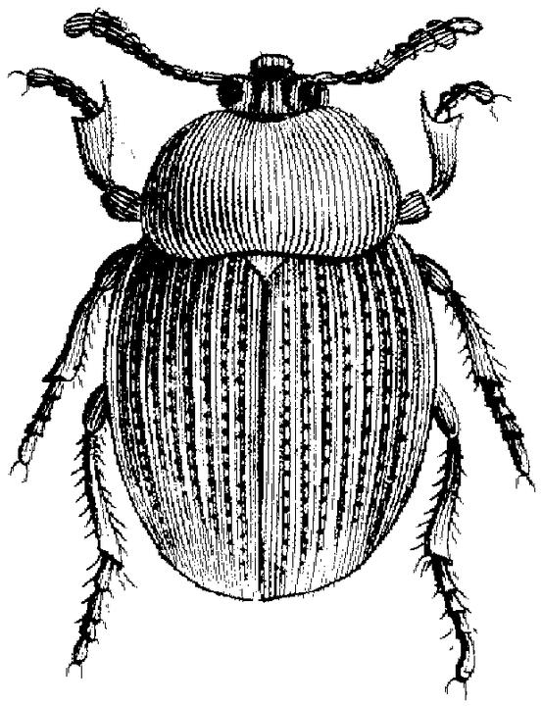 | 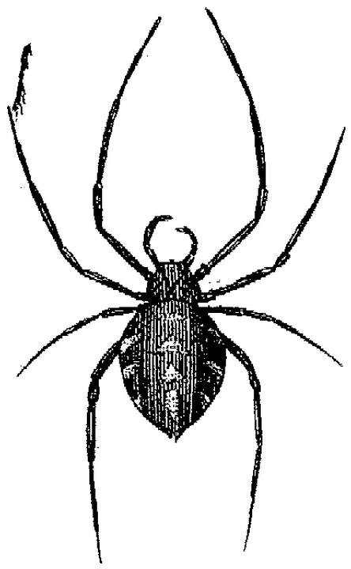 | 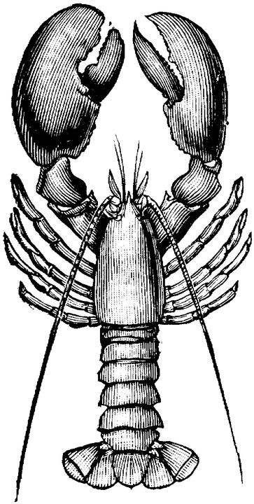
An insect | An arachnid | A crustacean
Observe the pictures above: What do all of these arthropods have in common?
One thing they have in common is . . .
Another thing they have in common is . . .
Write a well written paragraph using your observations and the sentence patterns above.

Now observe some more insects, arachnids, and crustaceans and try to find some differences:

Insects
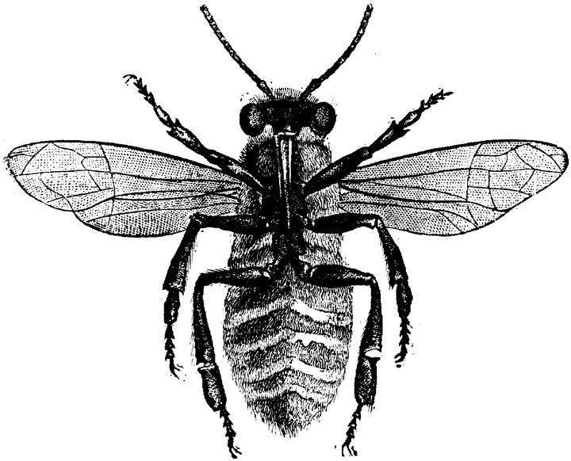 | 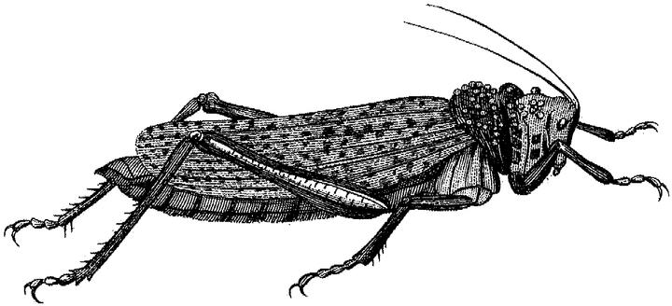 |  | 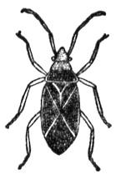

Arachnids
 | 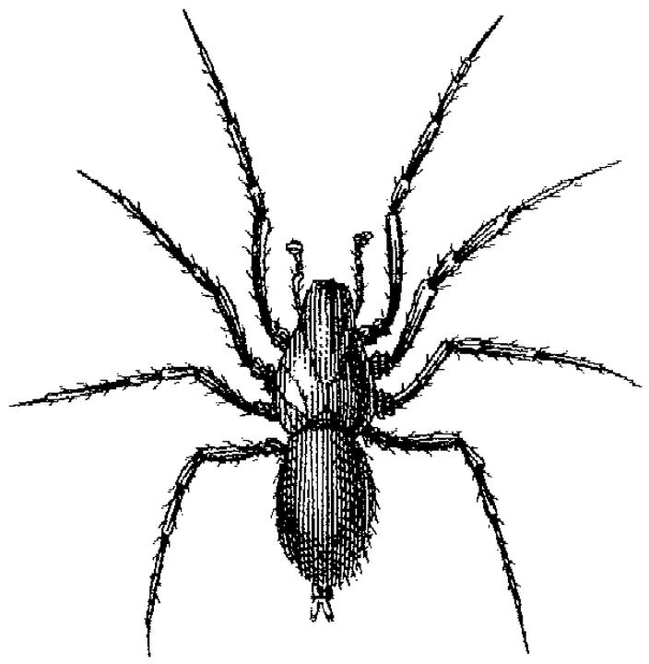 | 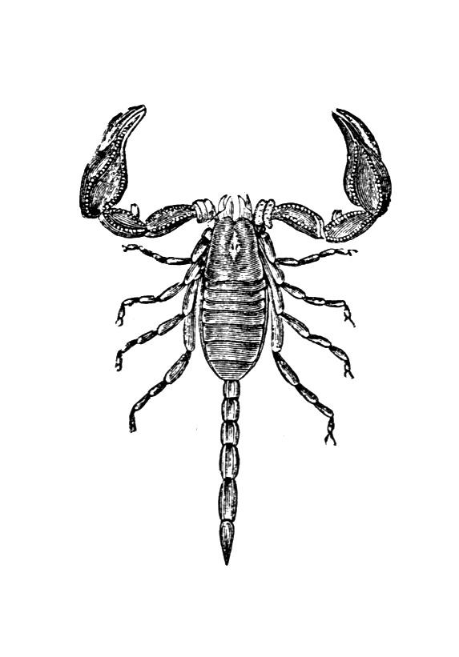

Crustaceans
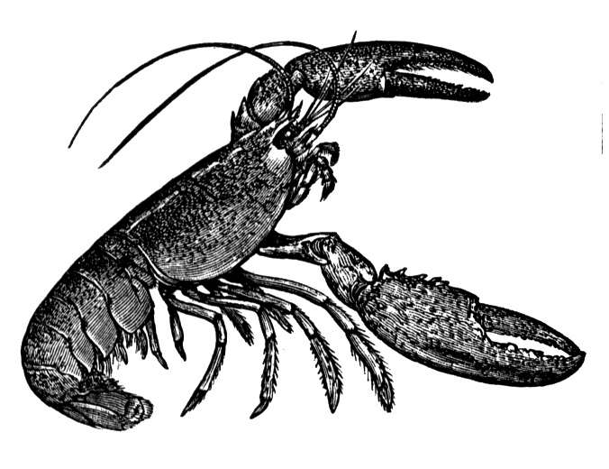 | 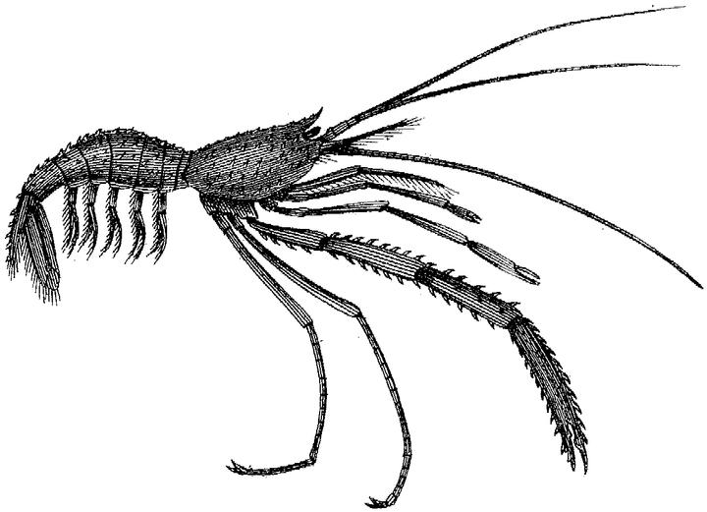 |  | 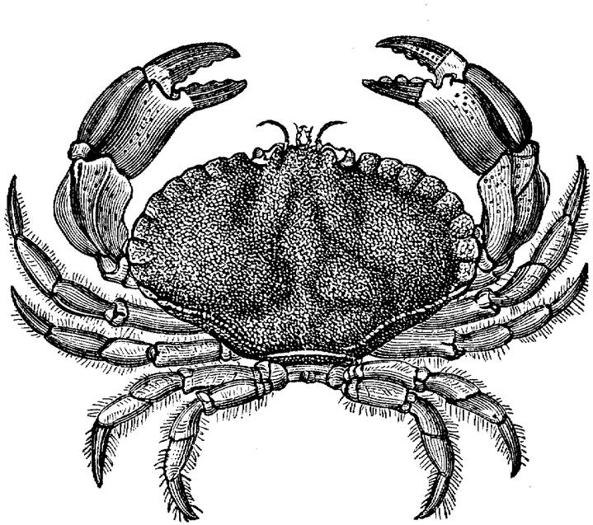
What differences can you observe?

Comparing and Contrasting:
When you compare something you find things that are similar. When you contrast something you find things that are different.

Look at these sentences and decide if the two objects are similar or different. Write similar or different in the blank space:

____________ Both spiders and scorpions have eight legs.
____________ Scorpions have claws but spiders don’t.
____________ Some scorpions are poisonous and some spiders
are poisonous as well.
____________ Unlike scorpions, spiders don’t have a tail.
____________ Spiders and scorpions are both arachnids.
____________ All scorpions are nocturnal, whereas spiders can be diurnal or nocturnal.
____________Like scorpions, spiders have two main body parts, a head and an abdomen.

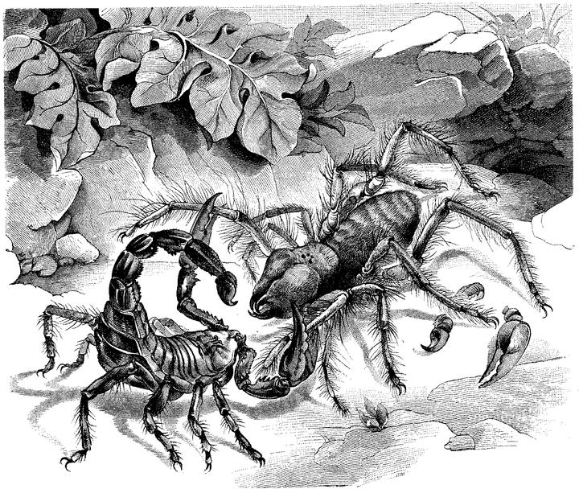 | Patterns to compare:
both. . . and . . .
Like . . . ,
. . . as well.

 | Patterns to contrast:
. . . but . . .
Unlike . . .
. . . whereas . . .

What does nocturnal mean? Can you think of some nocturnal animals?

What does diurnal mean? Can you name some diurnal animals?

Contrasting and Comparing Arthropods:
Features | Insects | Arachnids | Crustaceans
Body Parts | Three:  head, thorax, abdomen | Two:  cephalothorax*, abdomen | Two:  cephalothorax*, abdomen
Antennae | One pair | None | Two pairs
Legs | 3 pairs | 4 pairs | Usually 5 pairs  Sometimes more

*A cephalothorax is a body part that is a head and a thorax combined into one.

Write 9 sentences comparing these three classes of arthropods. Try to use all of the patterns of comparison and contrast that you see on the other page.

